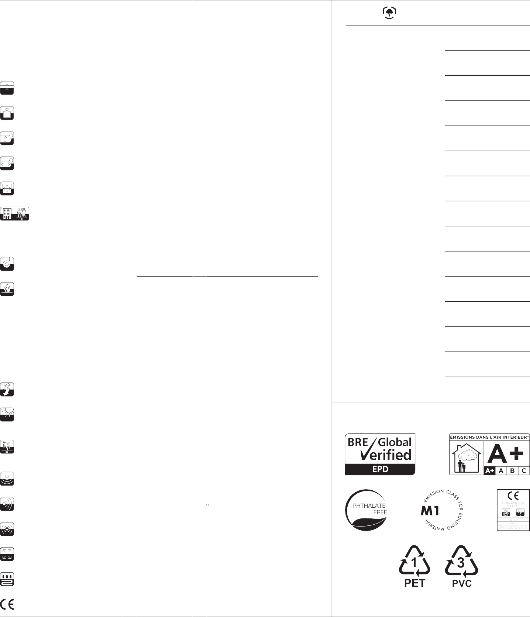

TECHNICAL INF
O

GARANTİ |  |  |  | 10 years* |  | Environme | nt, health and safety
YAPI |  |  |  | 83% vinyl - 7% fiberglass - 10% PET |  | Recycled Content | 10%
TABAN |  |  |  | Vinyl + Felt |  | Reach | Compliant
TOPLAM KALINLIK |  | ISO 1765 |  | 5mm - 0.20" |  | LEED v4 | Compliant  (LEED Contributing Product)
TOPLAM AĞIRLIK |  | ISO 8543 |  | 3000 g/m² - 88.5 oz/yd² |  | CDPH Standard Method V1.2 | Pass
RULO ENİ |  | EN ISO 24341 |  | ca. 200cm - ca. 6'7" |  | BREEAM® International | Compliant
RULO UZUNLUĞU |  | EN ISO 24341 |  | ca. 30m - 32.8 yd |  | BREEAM® NOR | Pass
KARO BOYUTU  Her kutuda 16 adet |  | EN 994 |  | 50cm x 50cm - 19.69" x 19.69" |  | French VOC Regulation | A+ Certified
KULLANIM DAYANIKLILIĞI |  | EN 1307 ASTM D5252 |  | Class 33  Heavy commercial use |  | French CMR components | Pass
YÜRÜME TRAFİĞİ TESTİ |  | ASTM D6119-12 |  | Heavy traffic |  | AGBB/ABG | Pass
TEKERLEKLİ SANDALYE  TESTİ |  | EN 985 |  | Continuous use |  | Belgian VOC Regulation | Pass
YANGINA DAYANIKLILIK |  | EN 13501-1 |  | Bfl-s1 |  | Indoor Air Comfort Gold | Pass
 |  | ASTM E 84  UL 723 |  | Class I or A rating
 |  |  |  |  |  | Blue Angel (RAL UZ120) | Pass
KRİTİK RADYAN AKIŞI |  | ASTM E648-15e1 NFPA |  | 0,84 W/cm² Class I |  | EN 717-1 | E1
DUMAN YOĞUNLUĞU |  | ASTM E622 |  | < 300 |  | M1 Protocol of July 2017 | Pass
YÜRÜME TESTİ |  | ISO 6356  AATCC 134-2006 |  | < 2 kv  Permanently antistatic |  | Plasticizer Content | Phthalate Free
SOLMAZLIK |  | ISO 105-B02 |  | ≥ 7
KAYMAZLIK |  | EN 13893  ASTM C1028-07 DIN 51130  EM 13036-4 |  | ≥ 0,3  0,85  R9 65
DARBE SESİ AZALTMA |  | ISO 10140 |  | 19dB
AKUSTİK EMİLİM |  | ISO 354 |  | w = 0,15
AYAK SESİ AZALTMA |  | EPLF 021029-3 |  | SL70
BOYUTSAL DURAĞANLIK |  | EN 986  ISO 2551 |  | Meets the requirements
ISI DAYANIMI |  | ISO 8302 |  | Suitable for underfloor heating
CE Certificate |  | EN 14041 |  | 0493-CPR-0151
Co2 neutral on demand
* Terms and conditions are available on request

2tec2 • 284 Chaussée d’Aelbeke, 7700 Mouscron, Belgium info@2tec2.com • www.2tec2.com

